Ques1: Write a program to take input ( a number) of a month (1 - 12) and print its equivalent name of the month.( e.g. 1 to Jan, 2 to Feb. 12 to Dec.) Use Scanner class for user input( Hint-use switch case).

Source Code

**package** Lab3;

**import** java.util.*;

**public** **class** SayMonth {

**public** **static** **void** main(String args[]) {

System.***out***.println("Hitendra Sisodia");

System.***out***.println("500091910");

Scanner sc = **new** Scanner(System.***in***);

System.***out***.print("Enter the month: ");

**int** input = sc.nextInt();

**switch**(input) {

**case** 1:

System.***out***.println("January");

**break**;

**case** 2:

System.***out***.println("February");

**break**;

**case** 3:

System.***out***.println("March");

**break**;

**case** 4:

System.***out***.println("April");

**break**;

**case** 5:

System.***out***.println("May");

**break**;

**case** 6:

System.***out***.println("June");

**break**;

**case** 7:

System.***out***.println("July");

**break**;

**case** 8:

System.***out***.println("August");

**break**;

**case** 9:

System.***out***.println("September");

**break**;

**case** 10:

System.***out***.println("October");

**break**;

**case** 11:

System.***out***.println("November");

**break**;

**case** 12:

System.***out***.println("December");

**break**;

**default**:

System.***out***.println("Enter Valid Month");

}

}

}

Output

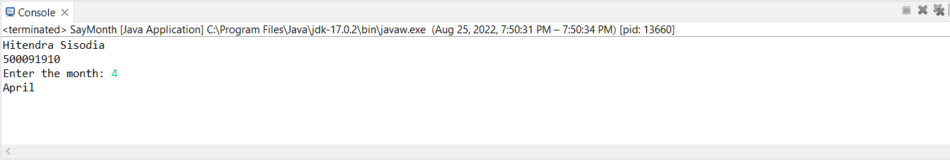

Ques2: Write a program to add two number using command line arguments.

Source Code

**package** Lab3;

**import** java.util.*;

**public** **class** SumOfNumbersUsingArguments {

**public** **static** **void** main(String args[]) {

System.***out***.println("Hitendra Sisodia");

System.***out***.println("500091910");

// parseInt is used to convert string to integer

**int** a = Integer.*parseInt*(args[0]);

**int** b = Integer.*parseInt*(args[1]);

**int** c = a + b;

System.***out***.println("The sum of a "+"and b "+" is: "+c);

}

}

Output

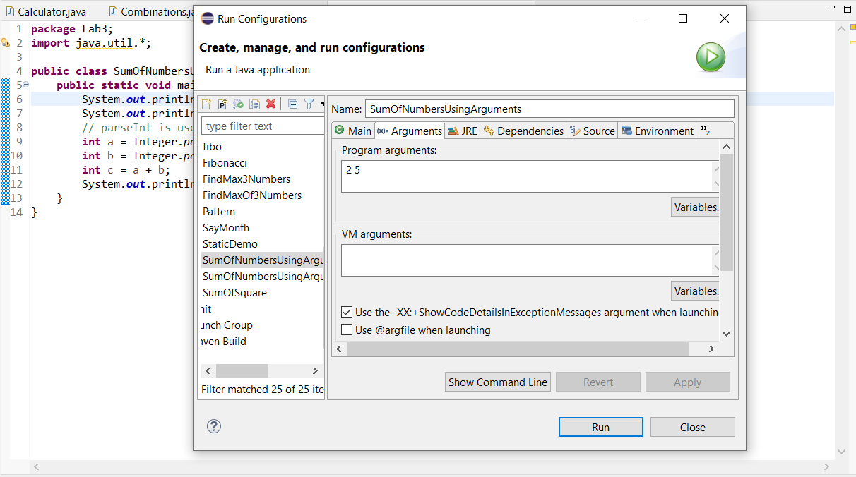

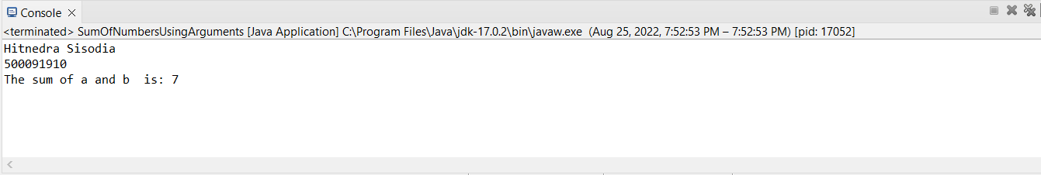

Ques3: Write a program to implement a command line calculator.Source Code

**package** Lab3;

**public** **class** Calculator {

**public** **static** **void** main(String args[]) {

System.***out***.println("Hitendra Sisodia");

System.***out***.println("500091910");

**int** sum = 0;

**int** a = Integer.*parseInt*(args[0]);

String op = args[1];

**int** b = Integer.*parseInt*(args[2]);

**if**(op.equals("+")) {

sum = a + b;

}

**else** **if**(op.equals("-")) {

sum = a - b;

}

**else** **if**(op.equals("/")) {

sum = a / b;

}

**else** **if**(op.equals("*")){

sum = a * b;

}

**else** {

sum = 0;

}

System.***out***.println("The answer is:"+sum);

}

}

Output

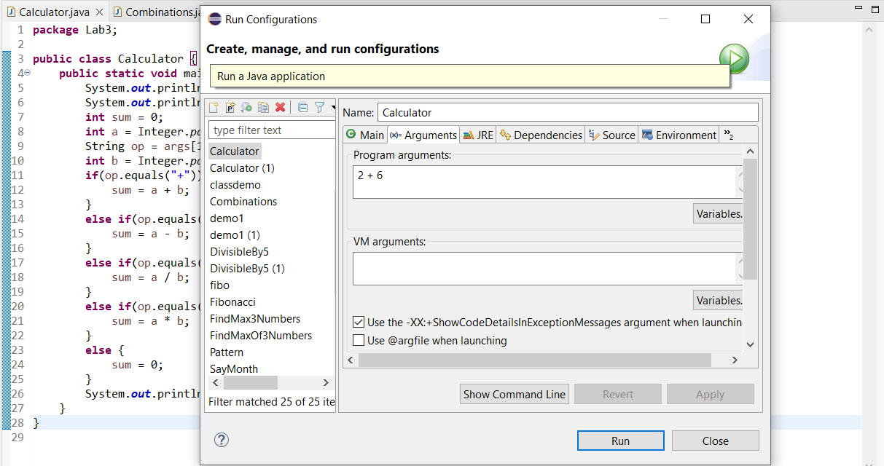

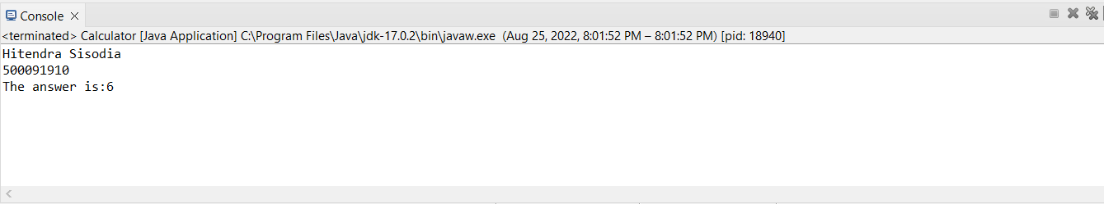

Ques4: Write a program to accept three digits (i.e., 0 - 9) and print all its possible combinations. (For example, if the three digits are 1, 2, 3 than all possible combinations are: 123, 132, 213, 231, 312, 321.).

Source Code

**package** Lab3;

**import** java.util.*;

**public** **class** Combinations {

**public** **static** **void** main(String[] args) {

Scanner sc = **new** Scanner(System.***in***);

**int** arr[] = {1,2,3};

**for**(**int** i = 0 ; i < 3 ; i++) {

**for**(**int** j = 0 ; j < 3 ; j++) {

**for**(**int** k = 0 ; k < 3 ; k++) {

**if**(i != j && j != k && k != i) {

System.***out***.println("["+arr[i]+" "+arr[j]+" "+arr[k]+"]");

}

}

}

}

}

}

Output

